In hamvoip
pacman -S alsa-lib alsa-utils
pacman -S lsb-release

Type alsamixer
Select the auto gain control
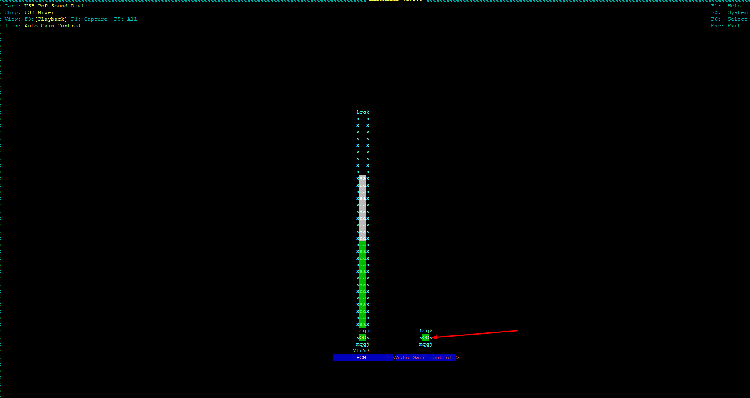

Press “M” to disable
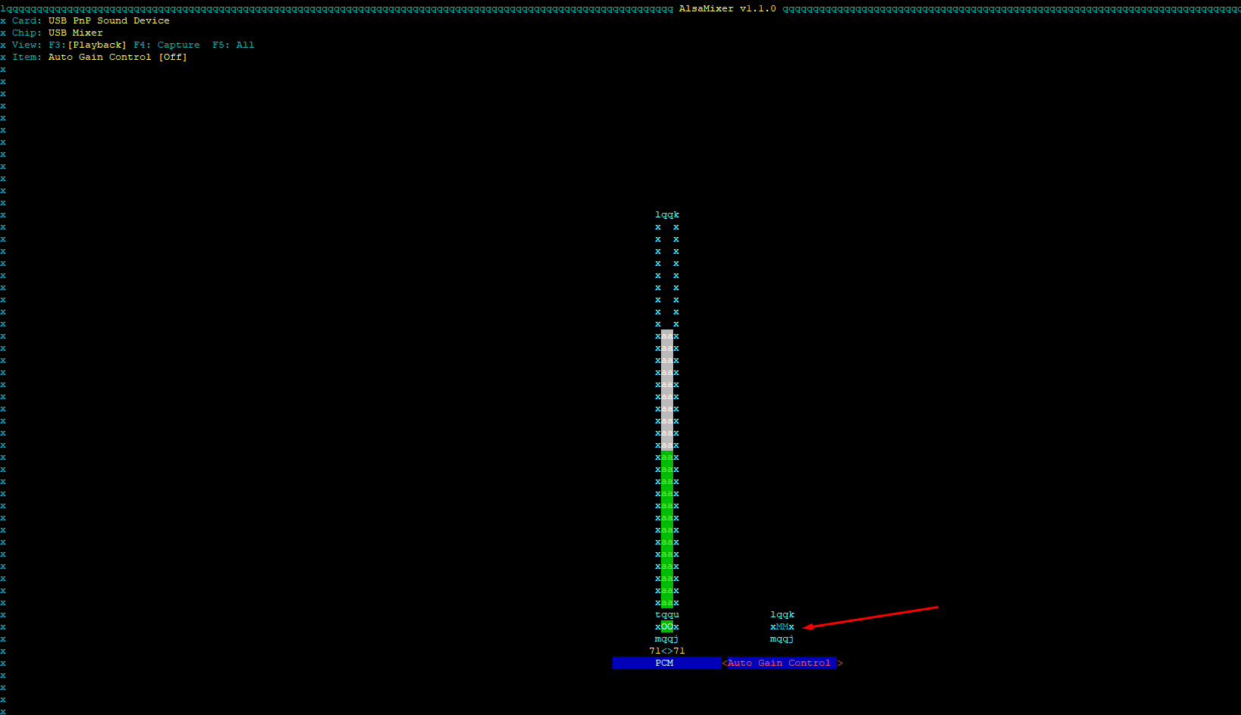

Then press tab until it shows like this below:-
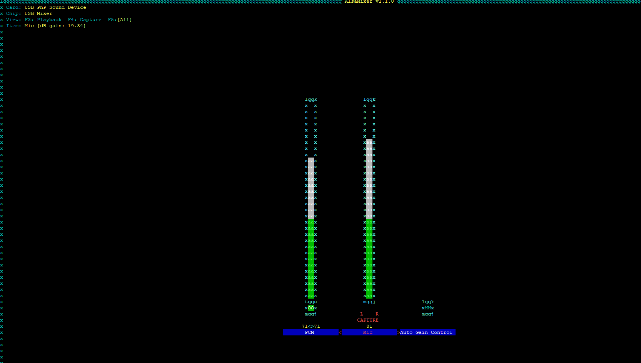
Then use <- , -> to select mic and PCM to adjust according to your level of audio input/output, test it with your Handly to echolink, and vice versa to get your optimized end results (sweatspot)

ESC will save your setting

